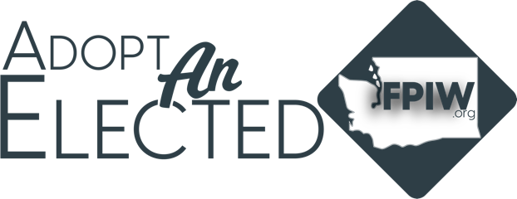

FEDERAL – UNITED STATES ..
President/Vice President
Donald J Trump/J D Vance
U.S. Senator
Maria Cantwell
Patty Murray

CONGRESSIONAL District ___________
U.S. Representative
________________________________________________

STATE – WASHINGTON STATE
Governor
Bob Ferguson
Lt. Governor
Denny Heck
Secretary of State
Steve Hobbs
State Treasurer
Mike Pellicciotti
State Auditor
Pat (Patrice) McCarthy
Attorney General
Nick Brown
Commissioner of Public Lands
Dave Upthegrove
Insurance Commissioner
Patty Kuderer

LEGISLTATIVE .District ___________
State Senator
________________________________________________
State Representative Pos. 1
________________________________________________
State Representative Pos. 2
________________________________________________

PRECINCT .NUMBER ___________
Precinct Committee Officer
________________________________________________

Judicial – WA SUPREME COURT
Justice Position #01
Mary I. Yu
Justice Position #02
Sal Mungia
Justice Position #03
Raquel Montoya-Lewis
Justice Position #04
Charles W. Johnson
Justice Position #05
Barbara Madsen
Justice Position #06
G. Helen Whitener
Justice Position #07
Debra L. Stephens
Justice Position #08
Steve Gonzalez
Justice Position #09
Sheryl Gordon McCloud

COUNTY
COMMISSIONER
________________________________________________
Assessor
________________________________________________
Auditor
________________________________________________
Clerk
________________________________________________
Prosecuting Attorney
________________________________________________
Sheriff
________________________________________________
Treasurer
________________________________________________

SCHOOL
Director Dist No. 1
________________________________________________
Director Dist N. 2
________________________________________________
Director Dist No. 3
________________________________________________
Director Dist No. 4
________________________________________________
Director Dist No. 5
________________________________________________

